

**Cruise Design Program**

**Users Guide**

**Version 2014_1029**

October 29, 2014

Washington Office

Forest Management Service Center

Fort Collins, Colorado

The U.S. Department of Agriculture (USDA) prohibits discrimination in all its programs and activities on the basis of race, color, national origin, sex, religion, age, disability, political beliefs, sexual orientation, or marital or family status. (Not all prohibited bases apply to all programs.) Persons with disabilities who require alternative means for communication of program information (Braille, large print, audiotape, etc.) should contact USDA’s TARGET Center at (202) 720-2600 (voice and TDD).

To file a complaint of discrimination, write USDA, Director, Office of Civil Rights, Room 326-W, Whitten Building, 1400 Independence Avenue, SW, Washington, DC 20250-9410 or call (202) 720-5964 (voice or TDD). USDA is an equal opportunity provider and employer.

Introduction 1

Getting Started 2

Create Design from Recon File 2

Design Strata From Historical Data 7

Setup Costs 8

Design Cruise 10

Sale Level 11

Strata Level 11

Sample Group Level 14

Designing a Cruise 15

Select Cruise Methods 16

Update any Missing Values 16

Optimize for Error 16

Modify Sample Group Information 17

Reports 17

FScruiser Button 18

Help 18

Return 18

Determine Additional Samples (Future Feature) 19

Compare Design with Production Cruise (Future Feature) 19

Exit 20

# Introduction

The Cruise Design Program was developed to aid in both training and production aspects of the cruise design process. Selecting between the various cruise methods available under the National Cruise Program and determining sample sizes to meet a specific sale error can be a confusing and time consuming process. The Cruise Design Program was designed to provide an interactive approach to designing a cruise by allowing a cruiser to examine many different cruise methods across many different strata and sample groups in a relatively short period of time.

The Cruise Design Program has several features that can assist a cruiser in the cruise design process.

1. Recon data can be accessed directly from a .cruise run through the Cruise Processing program.
2. Data from historical cruises or stand exam data can be input into the system if recon data is not available.
3. Multiple strata and sample group level determinations can be made when designing a cruise. These strata and sample groups are examined simultaneously to determine sample sizes that will achieve the desired sale error.
4. Strata and sample group level errors and sample sizes can be manipulated to achieve the desired over all sale error. Optimal allocation routines provide for ‘most efficient’ sampling sizes across strata and sample groups.
5. Sale, strata, and sample group errors are determined using actual t-values based on sample size for sample sizes less than 30.
6. A one-page comparison of all cruise methods provides for quick comparisons of CVs and sample sizes between cruise methods for each stratum.
7. Sampling frequencies and KZ values are computed and displayed in a report for each strata and sample group.
8. Cost analysis provides relative cost for each sampling method so comparisons can be made across sampling methods and across strata.
9. The program can create a new, complete .cruise file from the design information which can be loaded into FScruiser for data entry.

# Getting Started

The main menu displays the name of the program in the banner at the top (Figure 1). From the main menu to the left, you will initially be given five options: File, Setup, Design, Tools, and Exit. Only File and Exit are available until a file is opened.

The program will open the File option when starting the program providing the user with the following five options: Open an Existing Design File, Open a Production Cruise File, Create Design From Recon File, Create Design From Historical Data or Exit.

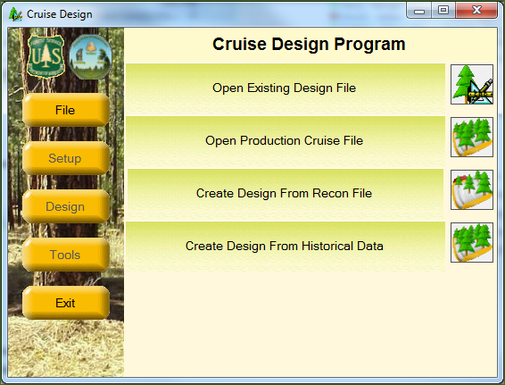

Figure 1 File Menu Screen

## Open Existing Design File

The Cruise Design program will save all cruise files with a .design file extension. To open an existing design file to continue working on the file, click the Open Existing Design File button. This will open the standard Windows open file dialog box, prompting the user to select an existing .design file.

## Open Production Cruise File

This option is currently under construction.

## Create Design from Recon File

Selecting this option will open the standard Windows open file dialog box, prompting you to select an existing .cruise file containing recon data. The recon .cruise file must be run through the Cruise Processing program before Cruise Design can work with the file. The Cruise Processing program adds the volume calculations to .cruise file. No specific reports need to be requested. Once the processed recon .cruise file has been selected, the *Setup, Design* and *Tools* buttons become active (Figure (2)).

## Setup

Before any analysis can take place, the user will need to define the sale populations. This is done under the **Setup** menu. Click on *Setup* to begin defining the sale strata and sample group information. Note: no strata information will be brought into Cruise Design from an existing .recon file. You will have to click on the *Design Strata From Recon Data* button to begin entering in strata information (Figure 2).

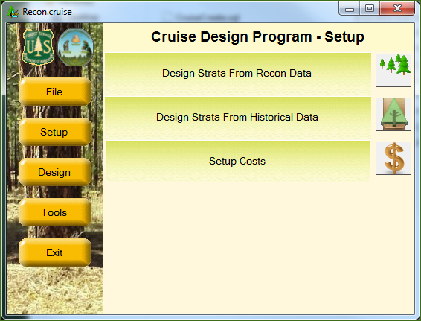

Figure 2: Setup Menu Options

Clicking on the *Design Strata From Recon Data* button will open the Strata Setup form. This will take some time initially as the Cruise Design program is creating the .design file and copying information from the .cruise file into the .design file. The .design file will have the same name as the recon .cruise file, but with the .design extension.

The cruise wizard forms are designed to walk the user through the strata and sample group setup process one step at a time. There are three steps required to define a stratum with one or more sample groups.

### Strata Setup Form

The Strata Setup Form (Figure 3) is where the user will define stratum codes and assign Units to the individual stratum. All of the units identified in the in the recon cruise will be displayed in the unit table.

To create a Stratum, click on the *Add Stratum* button in the upper left portion of the form. Give the stratum a Code (two digits max) and, optionally, a Description. Using a detailed strata description will help you identify strata during the design phase.

Next, select one or more units from the Unit Table by clicking on the *Select* box for the associated cutting units for each stratum (Figure 3). If no units exists (or additional units need to be added), clicking the *Add Unit* button will add a blank row to the end of the Unit Table. Each unit record requires a “Code” and “Area” in acres as the minimum amount of information to be entered.

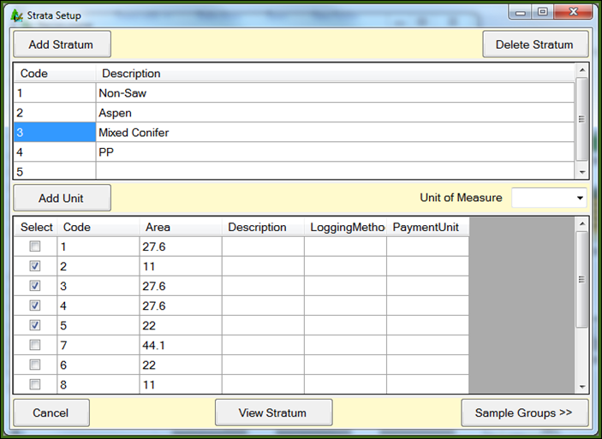

Figure 3: Strata Setup Form

Once the stratum has been created and units assigned, click the *Sample Groups* button in the bottom right corner of the form to create sample groups. This will open up a new form where sample group information can be entered. The user has the option of creating sample groups for each stratum as they are created or to create all strata first, then filling in sample groups for each stratum.

The View Stratum button will take the user to the View Strata Form. This form will allow the user to examine all stratum and sample groups defined.

### Sample Group Setup Form

The Sample Group Setup Form (Figure 4) is where the users will create sample groups for each of the defined stratum. The associated stratum number is displayed in the *Stratum* field located at the upper right have corner of the form. There are also fields for SG Set and Description, which will be discussed further down. The SG Set field is read only and will be set to the number ‘1’ initially.

Every stratum must have at least one sample group. To create a new sample group, click on the Add New SG button. A new line is added to the sample group table. Enter a sample group code

Figure 4-Sample Group Setup Form

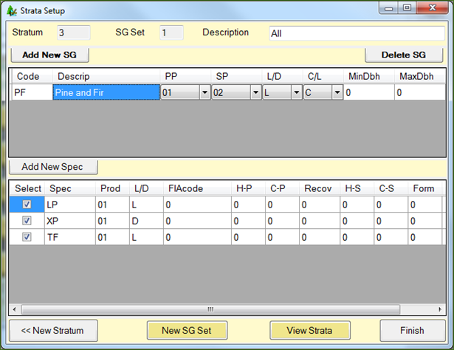(up to two digits) and a description. Select the Primary Product, Secondary Product, default Live/Dead code, and Cut/Leave code for the sample group using the pull down lists.

If diameter ranges will be used to define populations, enter diameter limits for each sample group in the MinDbh and MaxDbh columns (Figure 5). Diameter breakpoints must be entered with a precision of 0.1 inch (e.g., 24.9) to ensure each tree is placed within a population. If 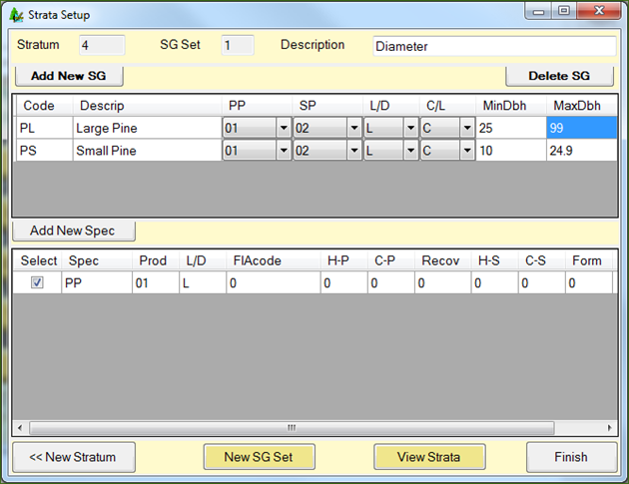stratifying by diameter class, use the same diameter range for all sample groups in the stratum. If using diameter ranges to denote sample groups, each sample group should have a separate diameter range. Take care not have gaps between the diameter ranges or overlapping diameter ranges. Note: when creating a diameter class with only a lower bound, it is a good idea to enter a dummy variable for the maximum diameter (e.g., 99) to ensure all large trees are included in the cruise design.

Figure 5 - Defining Populations by Diameter Class

Once a sample group has been defined, it needs to be populated with species. In the bottom half of the window is where the species codes for each sample group will be selected. This list will only show species from the Recon cruise that showed up in the stratum’s selected units. The list will also be filtered to only show those rows containing the same Primary Product code selected for the sample group. To add species to the selected sample group, click one or more boxes in the Select column.

If a species code is missing, click the *Add New Spec* button. A new window will pop up with a list of all default species codes that came with the .recon file (Figure 6). If there is a species code not available that you need to add, click the *Add New* button in the bottom left corner which will yield a blank row at the bottom of the window requiring you to enter pertinent species code information. Once all additional species codes are selected, hit Return in the bottom right corner to close this window.

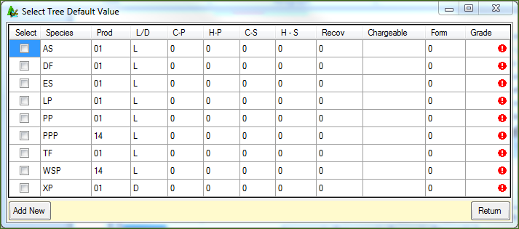

Figure 6 - Add Tree Species to List

#### SG Set

The SG Set is a new feature allowing the user to create more than one set of sample groups. For example, the user can lump all species together in one sample group code in the first SG Set then create a second SG Set and create sample groups for each species. In this way, the user can easily switch between SG Sets when designing the cruise to see how different designs affect different cruise methods. The Description field should be used to identify your SG Sets so they can be selected easily during the design phase. For example you can enter a description to help signify whether your sampling method is plot-based (All) or tree-based (By Species). To create a new SG Set, click the *Add New SG Set* button to create a new sample group table. The SG Set code will be incremented by one. The user will have the ability to create several SG Sets for each created stratum.

Once all of the sample groups for the currently selected stratum have been created, the user can select one of the following options:

New Stratum: This button takes you back to the Strata Setup window.

View Strata: This button will take you the View Strata form. This form will allow the user to examine all stratum and sample groups defined.

Finish: Once all of the sample groups for all of the strata have been created, Finish will exit the setup wizard and return the user back to the main form.

### View Strata Form

The View Strata Form (Figure 7) is used to review populations and allow the user to select a specific population for editing. At the top is a navigation control allowing the user to scroll between strata. Below that are three panes of information: Stratum & SG Set information, sample group information, and tree information (Figure 8). Selecting a stratum from the navigation bar will display a list of all SG Sets defined for that stratum. Selecting an SG Set will display all of the Sample Groups defined for the specific SG Set. Selecting a Sample Group will display all of the Species codes selected for that Sample Group.

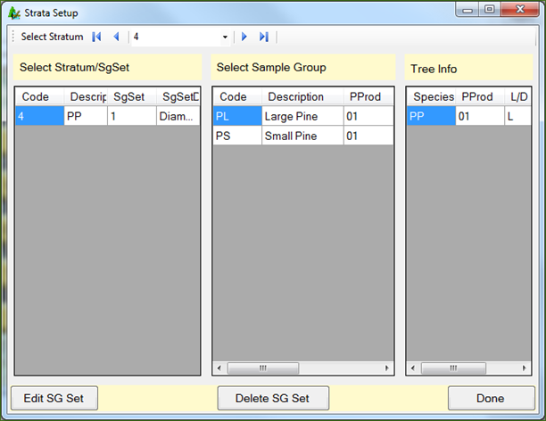From this form, the user is able to select a specific SG Set for editing by clicking the *Edit SG Set* button. This will take the user back the Sample Group Form. To delete a specific SG Set and all corresponding Sample Groups, select the desired SG Set and click the *Delete SG Set* button. When finished reviewing the stratum information, the *Done* button will take you back to the main Strata Setup form.

Figure 7 - View Stratum Form

## Design Strata From Historical Data

A new feature of this version of Cruise Design allows the user to create and design strata based upon data from historical cruises that occurred in forests similar to those in your current sale area. To use this feature, click on the *Design Strata From Historical Data* button to open up the “Historical Setup” window (Figure 8). From here, there are four steps for creating strata from historical data:

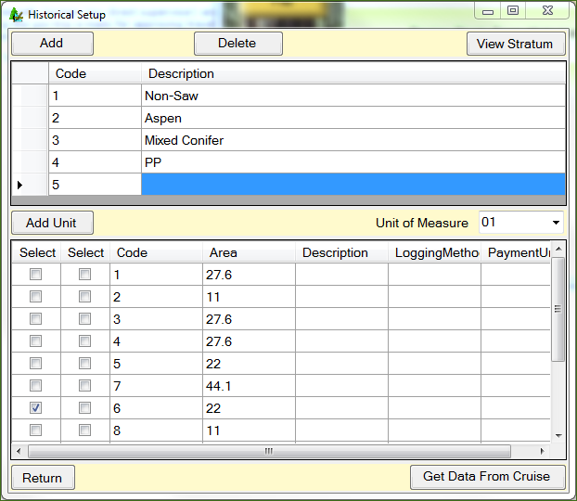

Figure 8 - Historical Setup Form

**Step 1**: Click the Add button to create a new row at the bottom of the strata list. Fill in the “Code” and, optionally, the “Description” boxes. Using a detailed strata description will help you identify strata during the design phase. Strata group codes are limited to two alpha-numeric characters maximum.

**Step 2**: Select the cutting unit you want this historical information to apply to by clicking on the *Select* box for the associated cutting units.

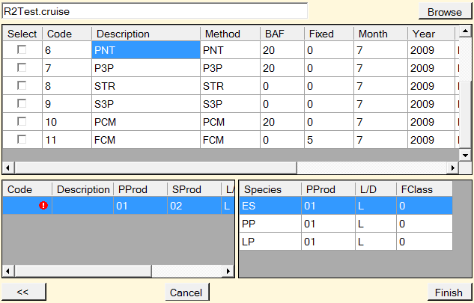**Step 3**: Click the *Get Data From Cruise* button to open up the standard Windows open file dialog box, prompting you to select the historical .cruise file. Once the historical cruise file is opened, select from the list of historical cruise strata the population to be used (Figure 9). The cruise design program will create the stratum and sample groups based on the historical data and utilize all of the calculated statistics. Once the stratum has been selected, click on Finish to return to the main screen. If more than one stratum need to be defined using historical data, click on the **<<** button to return to the Historical Setup main form.

Figure 9 - Select Historical Stratum Form

**Step 4**: Click the Return button in the bottom left corner to close the Historical Setup window.

## Setup Costs

In an effort to improve upon the cost determinations, a form has been created to determine relative cruising costs (Figure 10). The form makes use of hourly crew costs and the time it takes to do certain activities. The estimated values entered in this form will be used later for comparing costs between different cruise methods and sampling intensities. Enter as much information as you have available, or that you can reliably estimate.

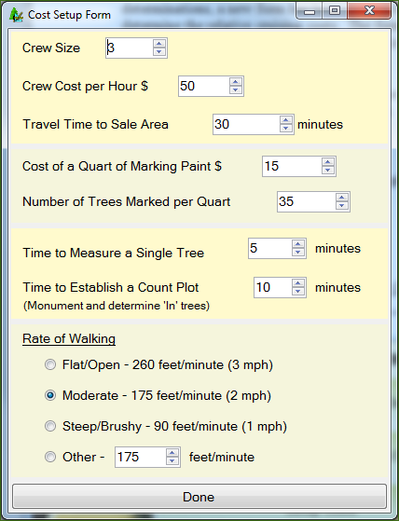

Figure 10-Cost Setup Form

Crew Size: Enter the number of individuals your cruising crew consists of.

Crew Cost per Hour $: Sum the hourly wages of you cruising crew and enter that number here.

Travel Time to Sale Area: Estimate the total time it will take your crew to get from the office to the timber sale area.

Cost of a Quart of Marking Paint $: If you wish to include the cost of paint to your cruise, you can enter the estimated cost of a quart of marker paint.

Number of Trees Marked per Quart: Estimate the average number of trees you can expect to mark with one quart. The number of quarts will be determined by dividing the total number of tallied trees by the estimated number of trees per quart.

Time to Measure a Single Tree: Estimate the time it takes a cruiser of average skill level to obtain the necessary tree-level measurements that will be collected for your timber cruise.

Time to Establish a Count Plot: Estimate the time it will take your crew to locate plot center, monument plot center, and determine the number of “in” trees, including measuring borderline trees, for the average plot in your sale area. Enter that number here.

Rate of Walking: This portion of the form assumes the average healthy timber cruiser walks at a pace of 3 mph in flat/open conditions as a baseline option, from which two other slower-paced options for walking rate can be selected. If you wish to specify a different walking rate, select the *Other* radio button and enter the rate by selecting the box and entering the rate, or by using the up/down arrows to arrive at your specified walking rate value.

When you have finished the form, select the *Done* button to return to the main menu.

# Design Cruise

Once all populations have been defined, click the Design button which will lead you to the Cruise Design Program-Design window (Figure 11). Select the Design Cruise button to design the cruise.

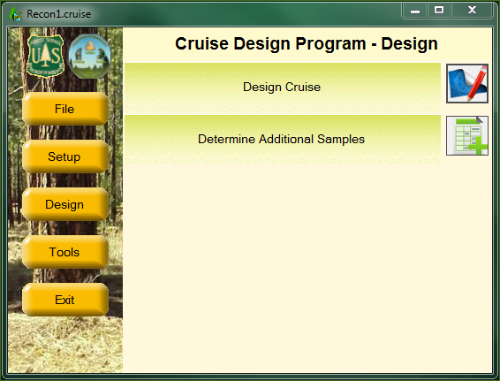

Figure 11-Cruise Design Program-Design Window

Once the data is processed, the Cruise Design Form will be displayed (Figure 12).The processing stage might take a little bit of time, depending on the amount of data the program has to process. The program will attempt to calculate the CVs, trees/acre, volume/acre, and sampling errors using every sampling method available in the Cruise Processing program for each defined Stratum and Sample Group. If there is no tree data for any given stratum or sample group, the program will assign default values for the CVs, trees/acre, and/or volume/acre. These default values will need to be updated by the user to their appropriate values.

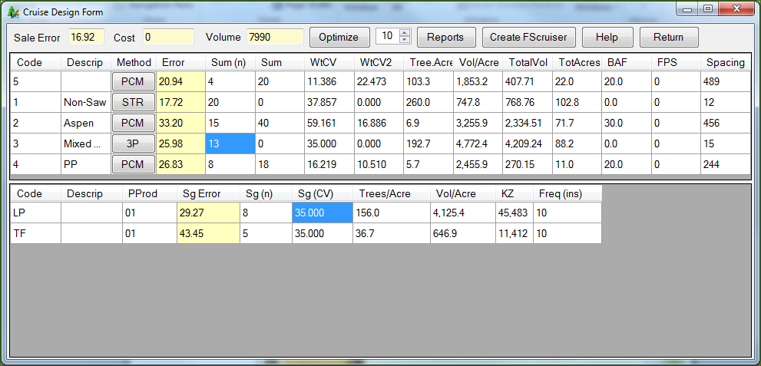

Figure 12-The Cruise Design Form

There is a lot of information displayed in the Cruise Design Form. To help manage the information, the Cruise Design Form is separated into to three basic sections: Sale level section, Strata level section, and the Sample Group level section.

Sale Level

The Sale Level is shown at the top left of the form. Basically, the Sale Level consists of the Sale Error, Cost and Volume fields.

Sale Error: The Sale Error is displayed in the first blue field and is the total combined error for the sale. The error is computed using the formulas shown in the Timber Cruising Handbook (FSH 2409.12).

Cost: The Cost is the estimated relative cost for the cruise as designed. It does not represent the actual cost to do the cruise, but it provides a number to compare against other designs for this sale. NOTE: the cost function is not yet working.

Volume: This is the total volume estimate for this sale. This number will be displayed as either CCF or MBF depending upon the Unit of Measure for the sale. Currently, only CCF is working.

Strata Level

The Strata Level information is displayed in the upper table. There are several columns of information displayed for each stratum. All of these columns are set to Read-Only with the exception of the Description and Vol/Acre fields. If you place your mouse over these columns headings, you will see a tool tip with a description of the field appears.

Code: Stratum code.

Descrip: Stratum description. This field is editable if you wish to add or modify a stratum description.

Method: The cruise method or sampling procedure that will be used to determine the sample trees for this stratum.

Error: Stratum Error. This is the combined sample group error determined by weighting each sample group error by the amount of volume occurring in each sample group. If there is only one sample group, the stratum error will equal the sample group error.

Sum (n): The total number of first stage samples to be taken for the Cruise Method. This number is the sum of the sample group number of first stage samples (see below).

Sum (n2): The total number of second stage samples to be taken for the Cruise Method. This number is the sum of the sample group number of second stage samples (see below).

WtCV: The Weighted CV value of the first stage samples for the Stratum. This number represents the sum of the sample group first stage CVs weighted by the volume for each sample group. This value is computed using the formulas shown in the Timber Cruising Handbook (FSH 2409.12).

WtCV2: The Weighted CV value of the second stage samples for the Stratum. This number represents the sum of the sample group second stage CVs weighted by the volume for each sample group. This value is computed using the formulas shown in the Timber Cruising Handbook (FSH 2409.12).

Trees/Acre: The total estimated trees per acre. This value is the sum of the sample group trees/acre value. If only one sample group exists, the stratum trees/acre will match the sample group trees/acre.

Vol/Acre: The total estimated volume per acre displayed in either cubic foot or board foot units depending upon the Unit of Measure for the sale. This value is the sum of the sample group trees/acre value. If only one sample group exists, the stratum trees/acre will match the sample group trees/acre.

TotalVol: The volume per acre multiplied by the total acres. This number will be displayed as either CCF or MBF depending upon the Unit of Measure for the sale.

TotAcres: Total acres for the Stratum.

BAF: Basal area factor used for the stratum (if applicable).

FPS: Fixed plot size displayed as the denominator of the Fixed Plot Size fraction (i.e., a 1/50 acre plot size would display as “50”).

Spacing: For plot-based methods, this is the recommended plot spacing for the Stratum. This value is based on the total acres for the stratum and the total number of plots (Sum (n)) established. For tree-based methods, this is the average tree spacing for the Stratum. This value is based on the estimated trees/acre value assuming square spacing.

If you click the button in the “Method” column for each stratum, a popup menu will appear containing options for selecting cruise methods for the stratum by SG Set (Figure 13).

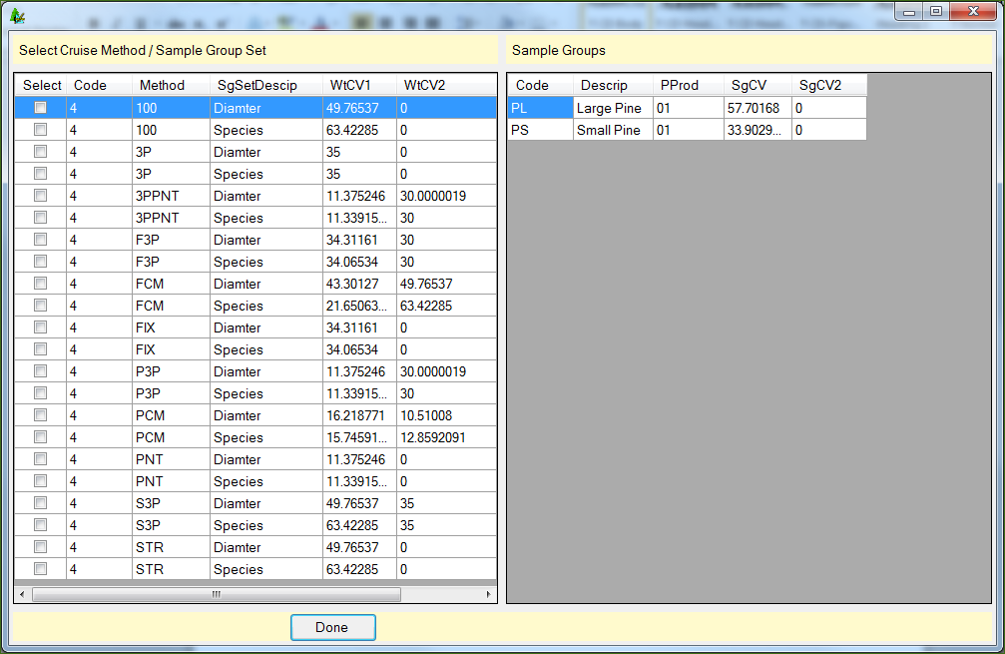

Figure 13-Window for Selecting Cruise Methods by Sample Group

The left half of this window contains information detailing sample group variability for that SG Set and specific sampling method.

Select: use this column to select the desired cruise method.

Code: Stratum code.

Method: Cruise method under consideration.

SgSetDescrip: Description of the sample group sets.

WtCV1: The Weighted CV value of the first stage samples for the sample group set.

WtCV2: The Weighted CV value of the second stage samples for the sample group set.

Description: Stratum description.

The right half of this window displays variability information for each individual sample group for the selected cruise methods.

Code: Sample group code.

Descrip: Sample group description.

SgCV: The estimated CV value of the first stage samples for the sample group.

SgCV2: The estimated CV value of the second stage samples for the sample group. This column will display as zero for one-stage sampling methods.

In the above example, there are two options for each cruise method with associated first and second stage weighted CVs for each option; the first being for all diameter classes, the second being for if we were to sample the two diameter class separately.

Sample Group Level

The Sample Group Level consists of the lower table. This table contains all of the sample group information for the currently selected stratum. This table is where most of the work is done. All of the values in this table are editable, except for Primary Product. You can change, for any sample group, the sample group error, the sample size, the estimated CV values, trees per acre, volume per acre, and so on.

There is quite a bit of information displayed in this table. The number of columns changes depending upon the cruise method selected. Below is the complete list of the columns that can be displayed in the sample group table.

Code: Sample group code.

Description: Sample Group Description.

PProd: Primary product code for the sample group.

Sg Error: Sample Group Error. This is the calculated sampling error for the sample group. The error will be computed using the floating Student’s T value instead of using a Student’s T value of 2.0.

Sg (n): The total number of first stage samples to be taken for the Cruise Method. For the Tree Based cruise methods 100, STR, and 3P, this number will represent the number of sample trees. For S3P, this number will represent the number of first stage samples or trees requiring a kpi estimate. For the Plot Based cruise methods PNT, FIX, F3P, P3P, PCMTRE, and 3PPNT, this number will represent the number of sample plots to establish. For the 100 percent cruise method, this number will be Read-Only and will be set to the product of the trees/acre for the sample group multiplied by total stratum acres.

Sg (n2): The total number of second stage samples to be taken for the Cruise Method. This column will only be displayed for 2-stage sampling methods (S3P, P3P, F3P, PCMTRE, 3PPNT). This number will represent the number of sample trees measured for all the 2-stage methods except 3PPNT, where the value will represent the number of sample plots to measure.

Sg (CV): The estimated CV value of the first stage samples for the sample group.

Sg (CV2): The estimated CV value of the second stage samples for the sample group. This column will only be displayed for 2-stage sampling methods (S3P, P3P, F3P, PCMTRE, 3PPNT).

Trees/Acre: The estimated number of trees per acre for the sample group.

Vol/Acre: The estimated volume per acre for the sample group displayed in either cubic foot or board foot units depending upon the Unit of Measure for the sale.

Trees/Plot: Estimated trees per plot for the Sample Group. This number is computed from the Recon data or set to a default value of 6. This column will only be displayed for the Plot Based cruise methods (FIX,F3P,PNT,P3P,PCMTRE, and 3PPNT).

Freq: Frequency; the rate at which a sample is determined. A frequency of 100 equates to one sample every 100 counts. This column will only be displayed for the STR, S3P, PCMTRE cruise methods and as a Read-Only field for the 100 percent cruise method. For the PCMTRE method, the Frequency value can be read as measure every xth tree or measure all the trees on every xth plot where x is the actual frequency value.

Freq (ins): Insurance tree frequency; the rate at which insurance trees are determined for selection behind the scenes. For example, an insurance frequency of 10 will identify every 10th sampled tree as an insurance tree.

BigBAF: The basal area factor used to select measure trees when taking the “BigBAF” approach for the PCM cruise method.

KZ: The KZ value for a 3P sampling method. This column will only be displayed for the 3P, S3P, P3P, F3P, and 3PPNT cruise methods.

Designing a Cruise

To design your cruise, you need to decide upon the cruise method you wish to use for each stratum and then take enough samples across all your strata and sample groups to meet your desired sampling error. The CruiseDesign program was specifically designed to help you accomplish this task.

There are several steps you should follow when designing your cruise: select cruise methods, update any missing values, optimize for a sale error, modify the samples for each strata and sample group, and create a report with your options. You may then wish to select new cruise methods and redo the process until you determine your ‘best’ cruise design.

Select Cruise Methods

For each stratum, you should select an appropriate cruise method. To change the cruise method, click on the button located in the “Method” column for each stratum (Figure 13). From the window, select the cruise method you wish to use. Initially, you should start simple. Select PNT instead of PCM or STR instead of 3P. Once you have designed a cruise with these options, move to the more complicated methods to compare the benefits (and costs) of using these methods.

Update Any Values

Look at each Stratum. Are there any missing values? If so, you will need to enter an appropriate value. Are there any values that don’t seem right? Is so, change the values based on your own experience. If the calculated CV is lower than you would have expected, raise it. Use your experience to supplement the data. Don’t worry about meeting any specific error at this point.

Optimize for Error

The *Optimize* button located at the top of the Cruise Design Form is designed to help the user determine how many samples are required in each stratum and sample group to meet a specific sampling error. To use the option, simply type in the desired sampling error in the field to the right of the button and click the button. You may use the scroll buttons or type the number in directly. Once the desired error has been entered, click the *Optimize* button.

There are several ways to optimally allocate the samples across multiple strata and sample groups. The CruiseDesign program optimizes the samples by using the CV values weighted by the corresponding volumes. The resulting samples are then modified to account for the floating Student’s T value. The result is the minimum number of samples needed to achieve the desired sampling error consistent with the way CruiseProcesssing will determine sale errors.

The results of this optimal allocation routine should be considered as your starting point to designing an adequate cruise design and not the ending point. The CruiseDesign program does not take into account any minimum strata level or sample group errors or the relative value of each of the strata. Although you will probably meet the desired sampling error with the calculated sample sizes (providing the CVs are accurate), the samples might not provide you with the information you need to adequately appraise your sale.

Modify Sample Group Information

Now that we have a starting point, we can modify the sample sizes to fine-tune our design. Changing values in the Sample Group table will automatically update other fields in the table as follows:

Changes to Sg (CV) or Sg (CV2): Changing the sample group CV value (Sg (CV) or Sg (CV2)) will modify the calculated sample group error (Sg Error).

Changes to Sg (n) or Sg (n2): Changing the sample group sample size (Sg (n) or Sg (n2)) will modify the calculated sample group error (Sg Error).

Changes to Sg Error: Changing the sample group error (Sg Error) will modify the calculated sample size (Sg (n) and Sg (n2)).

Changes to Freq or KZ: Changing either the frequency or the KZ value (Freq or KZ) will change the calculated sample size (Sg (n) and Sg (n2)) which will cause the sampling error (Sg Error) to be updated as well.

Changes to Trees/Acre: Changing the Trees/Acre value will update the frequency (Freq) value.

Changes to Vol/Acre: Changing the Vol/Acre value will update the KZ value.

Reports

When your design is completed, the Cruise Design Report will compile all of your Strata and Sample Group information into one report (Figure 14). The sale level information is provided at the top of the report, including the estimated sale error, estimated sum of net CCF or MBF, and the estimated cruise cost. For each defined Stratum, all of the stratum and sample group information is provided.

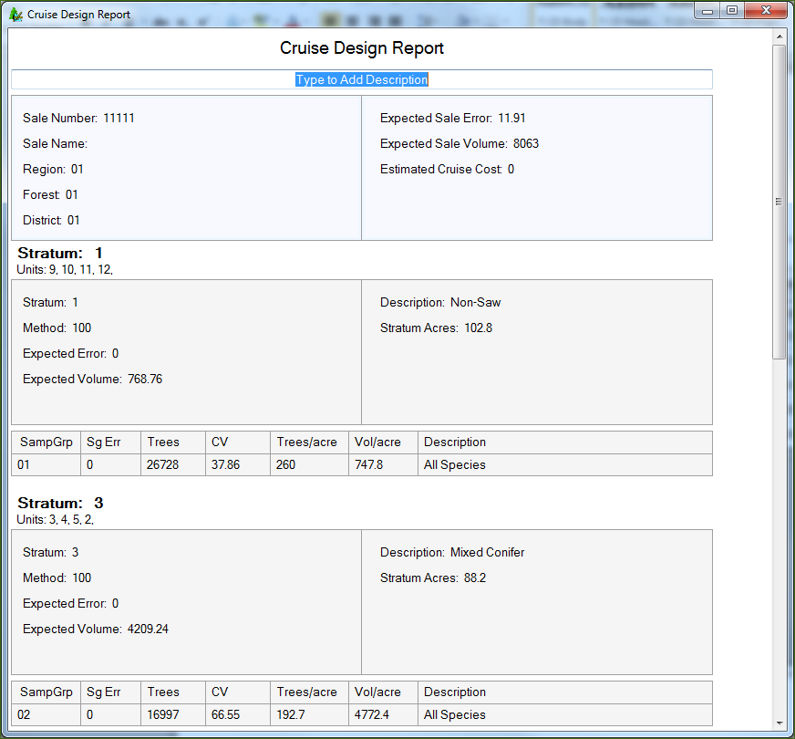

Figure 14-Cruise Design Report

The report can be printed or saved to a text file by right-clicking anywhere within the report and selecting Save or Print. This report can be used to document and/or compare other cruise designs.

FScruiser Button

The FScruiser button located at the top of the Cruise Design Form will create a new .cruise file for production cruise data entry. Tally screen information will be created for all Tree Based cruise methods and plot level information will be created for all Plot Based cruise methods.

To create a new production level .cruise file, click on the FScruiser button. This will open the standard Windows save file dialog box, prompting you to name the .cruise file you are about to save. Although the .cruise file may now be opened with the FScruiser program and used for data entry, the user will have to open the .cruise file in Cruise Manager to customize the tally fields for all tree based and two stage methods.

Help

This function is not turned on for this current beta version. Contact Ken Cormier by email at [kcormier@fs.fed.us](mailto:kcormier@fs.fed.us) with specific questions requiring assistance.

Return

Clicking the *Return* button will close the Cruise Design form, taking you back to the previous window with all changes being saved automatically.

Determine Additional Samples (Future Feature)

If during your production cruise you find that you have not met minimum sale or strata error requirements, the Determine Additional Samples function will allow you to calculate the number of additional samples needed to meet the error requirements.

Compare Design with Production Cruise (Future Feature)

If after completing your production cruise and adding additional samples you still have not met sale and/or strata error requirements, you have the option to use the Compare Design with Production Cruise tool for identifying what elements of your production cruise changed from the recon file.

Exit

Clicking the Exit button will close the program. All data will be saved automatically.